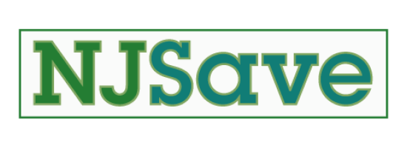

Programs Accessed Through NJSave

NJSave enrolls eligible applicants into the following programs:

* [Pharmaceutical Assistance to the Aged and Disabled (PAAD)](https://nj.gov/humanservices/doas/services/l-p/paad/)
* [Senior Gold Prescription Discount Program](https://nj.gov/humanservices/doas/services/q-z/senior-gold/)
* [Lifeline Utility Assistance](https://nj.gov/humanservices/doas/services/l-p/lifeline-utility/)
* [Medicare Savings Programs](https://nj.gov/humanservices/doas/services/l-p/msp/index.shtml) (QMB, SLMB & QI)
* [Medicare Part D's Low Income Subsidy (LIS, also known as "Extra Help")](https://www.ssa.gov/benefits/medicare/prescriptionhelp/)
* [Hearing Aid Assistance to the Aged and Disabled (HAAAD)](https://nj.gov/humanservices/ddhh/services/hearingaid/haaad/)

The application is also used to screen individuals for numerous savings and assistance programs.  If it looks like they may qualify, their data is forwarded on for enrollment.  These programs include:

* [Universal Service Fund (USF)](https://www.nj.gov/bpu/residential/assistance/usf.html)
* [Low-Income Heating and Energy Assistance Program (LIHEAP)](https://www.nj.gov/dca/dhcr/offices/hea.shtml)
* [Supplemental Nutrition Assistance Program (SNAP)](https://www.nj.gov/humanservices/dfd/programs/njsnap/)

Finally, individuals who qualify for PAAD and Lifeline Utility Assistance through NJSave may also be eligible for:

* [Property Tax Freeze](https://www.state.nj.us/treasury/taxation/relief.shtml)
* [Reduced Motor Vehicle Fees](https://www.state.nj.us/mvc/vehicles/regfees.htm)
* [Low-Cost Spaying/Neutering](https://www.state.nj.us/health/vph/pop-control/index.shtml)
* [NJ Hearing Aid Project](https://www.nj.gov/humanservices/ddhh/services/hearingaid/project/)

